**Now is time to explore using the spreadsheet I provided for guidance (you can adapt this spreadsheet in your own time).**

1. **Download the spreadsheet. I have shown you my exemplar “Law Tab”. Click tab Another Subject for you to enter the subject you are researching (create more tabs as required)**
2. **Make sure you are logged on to Morrisby Webspace (see screenshots at bottom of this document to remind you of important pages)**
3. **See attachment: Key Supra Curricular Resources 2020 and Subject Specific Resources for developing and demonstrating your interest (for Columns F & G in particular)**
4. **Choose which of the following applies best to you – 1, 2, 3 or 4 - (you may move between two) and get cracking…**
5. **You can copy across relevant things you found during the “Flash Tasks in the PSHE” (Flash Tasks Tab in Spredsheet**
6. **Remember this is an on-going task…. Remember you can adapt this spreadsheet as suits you over time**

**1) If You Don’t Know What You Want to Study (Ps. This is ok; even desirable!)**

* Do any of your school subjects appeal?
* Look at your Morrisby degree suggestions (screenshot 1 – foot of this doc)
* Look at your career interview write-up (if you have one) for more ideas
* What other sources of inspiration have you had?
* Look at subjects similar to ones you might explore in Morrisby course description (screenshot 2 – foot of this doc)
* Select some potential subjects from the above, use the Morrisby filtering tool to explore them at different universities (screenshot 3 – foot of this doc). You can supplement this with UCAS course search: <https://www.ucas.com/>
* Get university course link for the courses you identify and paste into spreadsheet so you can explore further (ensure a range – aspirational, happies, happy reserves) ***(Column A and B)***
* Explore the courses online. Note pros, cons **(Column C)**
* Think about questions that you want to find out and how you are going to find out more (eg. phone and open day, eg. what were your accepting people on results day last year)? ***(Column D)***
* If you complete this, move on to relevant subsequent columns… Remember to think of things from your A level subjects and super curricular (beyond your A levels) to demonstrate your interest

**2) You Want to Study A School Based Subject**

* Select some potential subjects from the above, use the Morrisby filtering tool to explore them at different universities (screenshot 3 – foot of this doc). You can supplement this with UCAS course search: <https://www.ucas.com/>
* Get university course link for the courses you identify and paste into spreadsheet so you can explore further (ensure a range – aspirational, happies, happy reserves) ***(Column A and B)***
* Explore the courses online. Note pros, cons **(Column C)**
* Think about questions that you want to find out and how you are going to find out more (eg. phone and open day)? ***(Column D)***
* Identify particular areas of the degree subject that currently interest you in class.  **(Column E)**
* Can you find ways to explore these particular subject interests further using reading (eg. Very Short Introduction to Guides), MOOCs, competitions and the other resources you have seen shown? **(Column F)**
* If you complete this, move on to subsequent columns….

**3) You’re Considering A New Subject**

* Look up at subjects similar to ones you might explore in Morrisby course description (screenshot 2 – foot of the doc)
* Select some potential subjects from the above, use the Morrisby filtering tool to explore them at different universities (screenshot 3). You can supplement this with UCAS course search: <https://www.ucas.com/>
* Get university course link for the courses you identify and paste into spreadsheet so you can explore further (ensure a range – aspirational, happies, happy reserves) ***(Column A and B)***
* Explore the courses online. Note pros, cons **(Column C)**
* Think about questions that you want to find out and how you are going to find out more (eg. phone and open day)? ***(Column D)***
* Identify *transferable skills* from your current subjects. See Mr M’s law example **(Column E)**
* Can you find ways to explore these particular subject interests further using reading (eg. Very Short Introduction to Guides), MOOCs, competitions and the other resources you have seen shown? **(Column G)**

**4) A vocational subject like medicine**

* Look up at subjects similar to ones you might explore in Morrisby course description (screenshot 2 – foot of this doc)
* Select some potential subjects from the above, use the Morrisby filtering tool to explore them at different universities (screenshot 3 – foot of this doc). You can supplement this with UCAS course search: <https://www.ucas.com/>
* Get university course link for the courses you identify and paste into spreadsheet so you can explore further (ensure a range – aspirational, happies, happy reserves) ***(Column A and B)***
* Explore the courses online. Note pros, cons **(Column C)**
* Think about questions that you want to find out and how you are going to find out more (eg. phone and open day)? ***(Column D)***
* Identify *transferable skills* from your current subjects. See Mr M’s law example **(Column E)**
* Can you find ways to explore these particular subject interests further using reading (eg. Very Short Introduction to Guides), MOOCs, competitions and the other resources you have seen shown? **(Column G)**
* Can you identify the competencies for the related career? Have can you or will you evidence these competencies to YOURSELF (so you know the related career appeals) and then to the Admissions Tutor for the course? **(Column H) REMEMBER: for healthcare courses Admissions Tutors will often be looking for significant evidence from volunteering and work experience of relevant skills and vocational commitment. Therefore your personal statement should often have a lot of this as well as some academic discussion**

**Screenshot 1: Morrisby degree ideas**

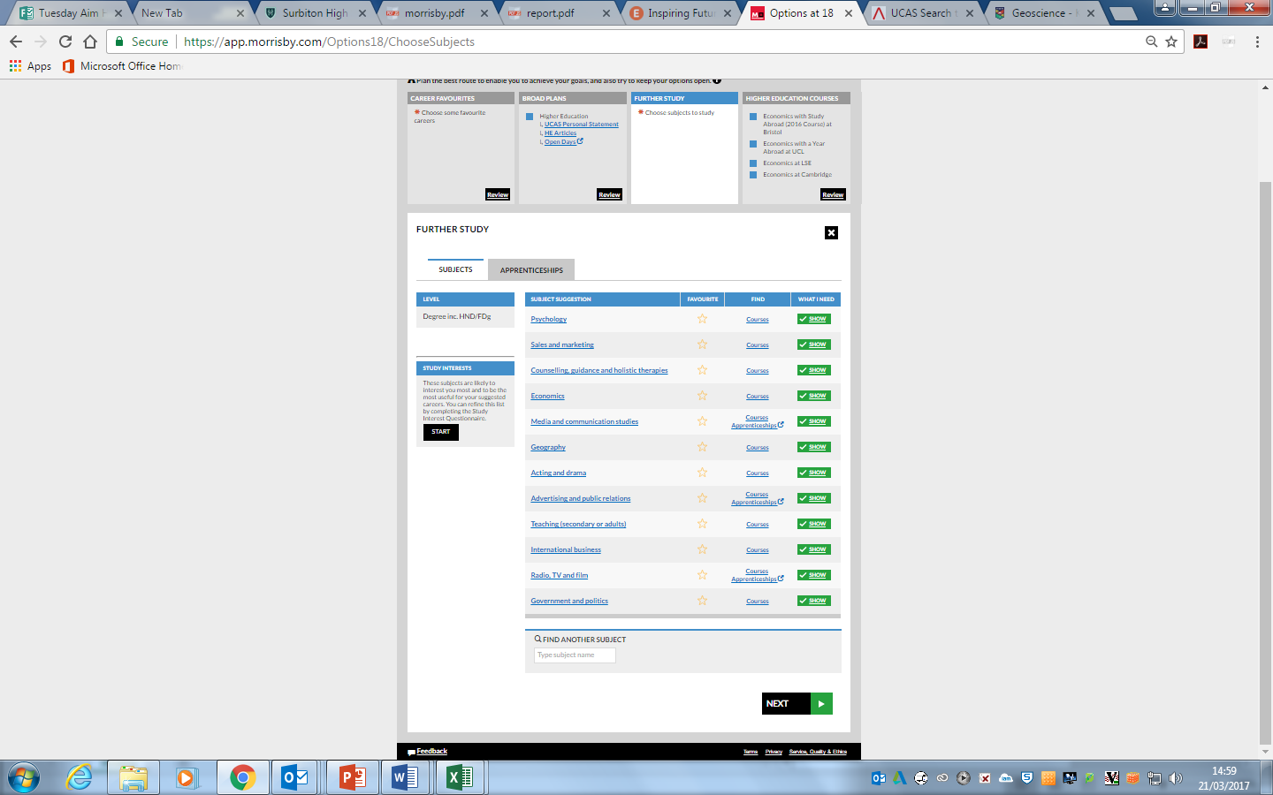

**Screenshot 2: Looking at “Similar Subjects”**

